

**The Bramble Academy,**

**Calculation Policy**

|  |  |
| --- | --- |
| **Document Owner** | Anna Harper |
| **Version** | 1 |
| **Effective From** | September 2023 |
| **Next Review Date** | September 2024 |

5 + 12 = 17

Place the larger number in smaller number to find your

answer.

Addition

Progression in Calculations

12 + 5 = 17

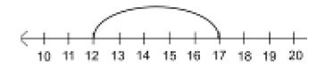

Start at the larger number on the number line and count on in ones or in one jump to find the answer.

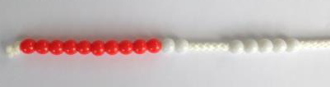

Start with the larger number on the bead string and then count on to the smaller number 1 by 1 to find the answer.

Starting at the bigger number and counting on

4 + 3 = 7

10= 6 + 4 5

3

Use the part-part whole diagram as shown above to

abstract.



Use pictures to add two numbers together as a group or in a bar.

8 1

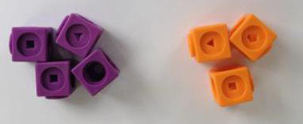

Use cubes to add two numbers together as a group or in a bar.

Combining two parts to make

a whole: part- whole model

Abstract

Pictorial

Concrete

Objective and

Strategies

move into the

your head and count on the















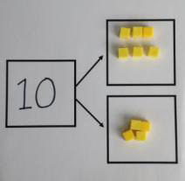





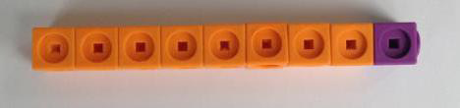





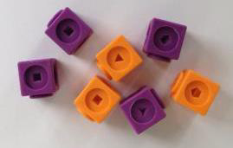

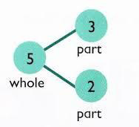

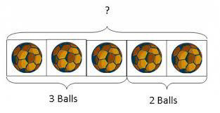



Partitioning two 2-digit numbers

Partitioning the tens, then the ones

22 + 12 =

20 + 10=

2 + 2 =

24 + 15=

Add together the ones first then add the tens.

the Base 10 blocks first before moving onto place value counters.

After practically using the base 10 blocks and place value solve additions.

T o

Column method- no

regrouping

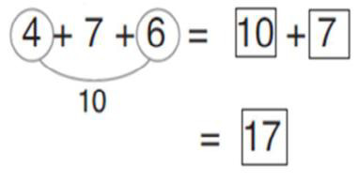

Combine the two numbers on the remainder.

+ +

+

Add together three groups of objects. Draw a

4 + 7 + 6= 17

Put 4 and 6 together to make 10. Add

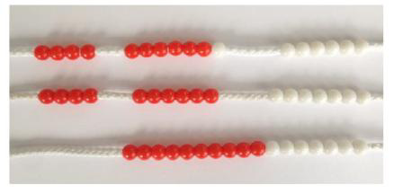

Following on from making 10, make 10 with 2 of the digits (if possible) then add on the third digit.

Adding three single digits

7 + 4= 11

If I am at seven, how many

How many more do I add on now?

Use pictures or a number line. Regroup or partition the smaller number to make 10.

6 + 5 = 11

Start with the bigger number and use the

smaller number to make 10.

Regrouping to make 10.

picture to recombine the groups to make 10.

counters, children can draw the counters to help them to

that make 10 and then add

on 7.

more do I need to make 10.

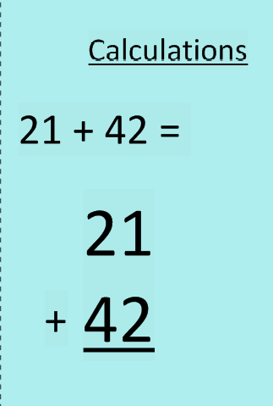

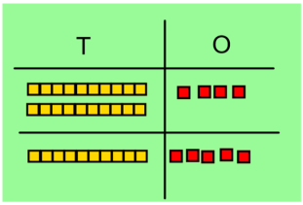

































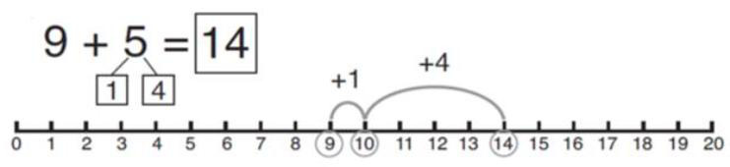

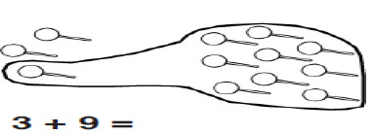



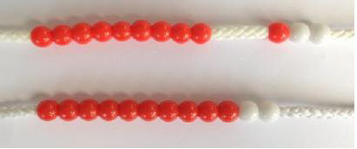

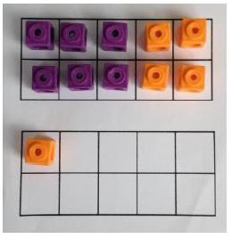























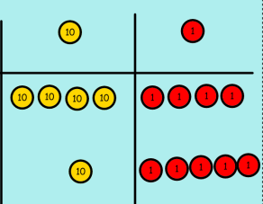

Start by partitioning the to clearly show the addition.

As the children move on, introduce decimals with

the same number of decimal places and different. Money can be used here.

Children can draw a pictoral representation of the columns and place value counters to further support their learning and understanding.

Make both numbers on a place value grid.

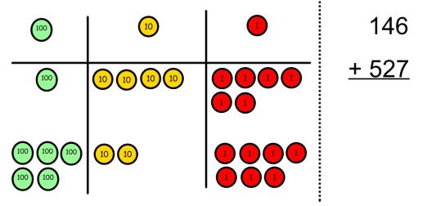

Add up the units and exchange 10 ones for one 10.

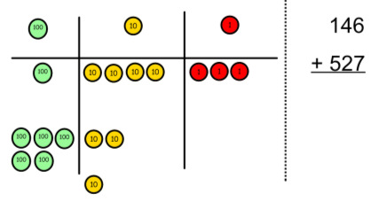

Add up the rest of the columns, exchanging the 10 counters from one column for the next place value column until every column has been added.

This can also be done with Base 10 to help children clearly see that 10 ones equal 1 ten and 10 tens equal 100.

As children move on to decimals, money and decimal place value counters can be used to support learning.

Column method-

regrouping

exchange below the

numbers before moving on

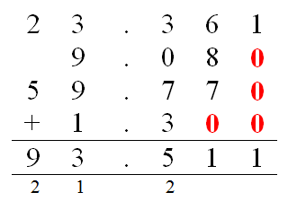

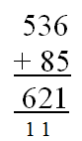

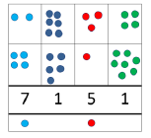



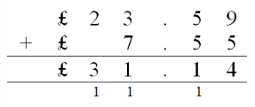

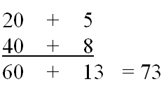





Put 13 in your head, count

you at? Use your fingers to help.

Count back on a number line or number track

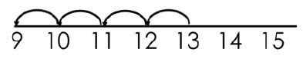

Start at the bigger number and count back the smaller number showing the jumps on the number line.

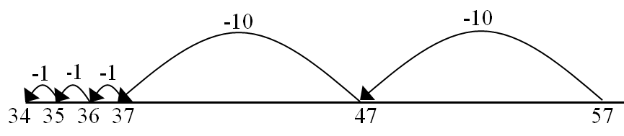

This can progress all the way to counting back using two

2 digit numbers.

Make the larger number in your subtraction. Move the beads along your bead string as you count backwards in ones.

13 - 4

Use counters and move them away from the group as you take them away counting backwards as you go.

Counting back

18 -3= 15

8 - 2 = 6

Cross out drawn objects to show what has been taken away.

Use physical objects, counters, cubes away.

6 - 2 = 4

Taking away ones

Abstract

Pictorial

Concrete

Objective and

Strategies

back 4. What number are

etc to show how objects can be taken

Subtraction

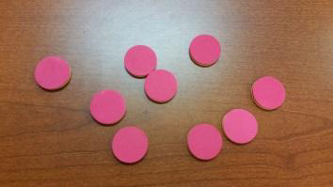

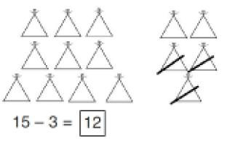









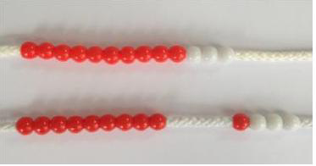





16 - 8=

How many do we take off to reach the next 10?

How many do we have left

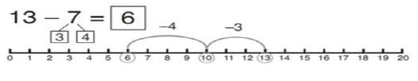

Start at 13. Take away 3 to reach 10. Then take away the remaining 4 so you have taken away 7 altogether. You have reached your answer.

14 - 9 =

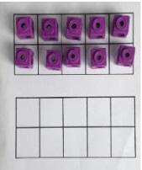

Make 14 on the ten frame. Take away the four first to make 10 and then takeaway one more so you have taken away 5. You are left with the answer of

9.

Make 10

5

10

Move to using numbers within the part whole model.

Use a pictorial representation of objects to show the part

Link to addition- use the part whole model to help explain the inverse between addition and subtraction.

If 10 is the whole and 6 is one of the parts. What is the other part?

10 - 6 =

Part Part

Whole Model

Hannah has 23 sandwiches,

Find the difference between the number of sandwiches.

Count on to find the difference.

Draw bars to find

the difference between 2 numbers.

Compare amounts and objects to find the difference.

Use cubes to build towers or make bars to find the difference

Use basic bar models with items to find the difference

Find the difference

to take off?

part whole model.

Helen has 15 sandwiches.













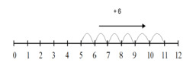

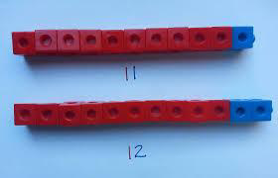

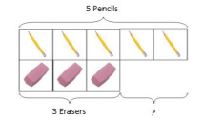



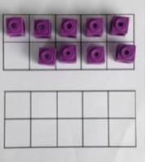



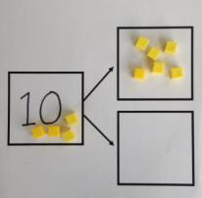

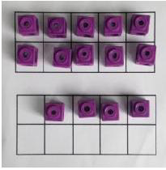

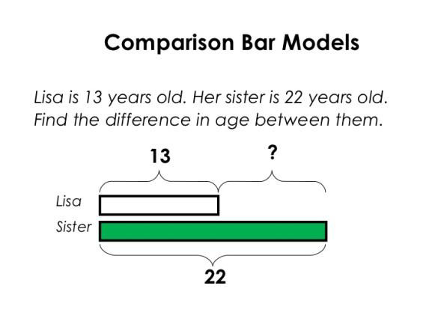

Draw the counters onto show what you have

the counters out as well as clearly showing the exchanges you make.

When confident, children can find their own way to record

Just writing the numbers as shown here shows that the child understands the method

and knows when to exchange/regroup.

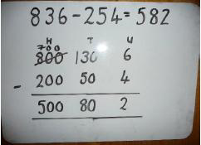

Children can start their formal written method by partitioning the number into clear place value columns.

Moving forward the children use a more compact method.

Use Base 10 to start with before moving on to place value counters. Start with one exchange before moving onto subtractions with 2 exchanges.

Make the larger number with the place value counters

Start with the ones, can I take away 8 from 4 easily? I need to exchange one of my tens for ten ones.

Column method with

regrouping

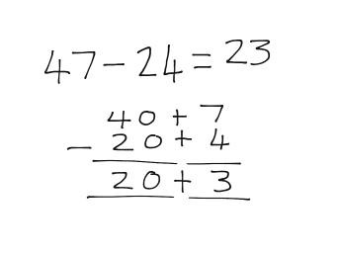

This will lead to a clear written column subtraction.

Draw the Base

value counters alongside the

calculation to help to show working.

Use Base 10 to make the bigger number then take the smaller number away.

Show how you partition numbers to subtract. Again make the larger number first.

Column method

without

regrouping

the exchange/regrouping.

taken away by crossing

a place value grid and

written

10 or place

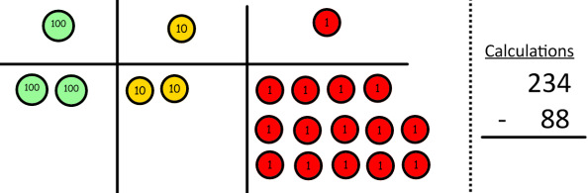

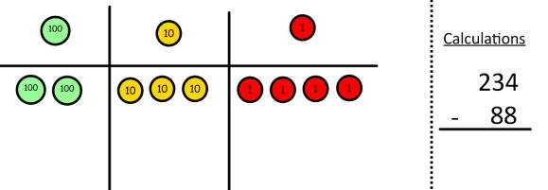



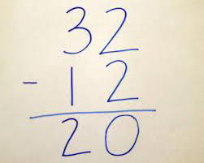

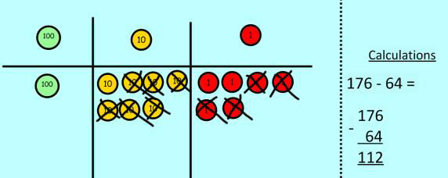

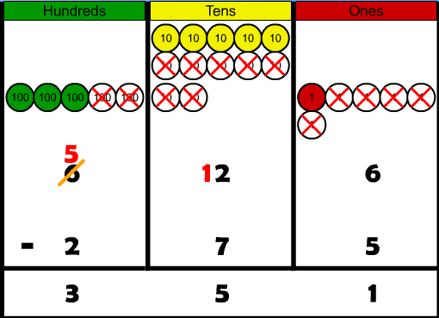

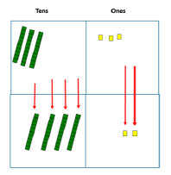

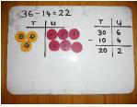



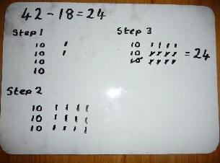

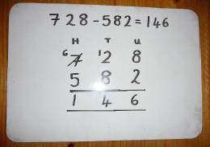

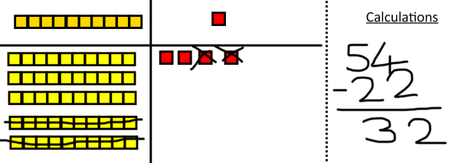

This will lead to an understanding of subtracting any number including decimals.

Now I can subtract my ones.

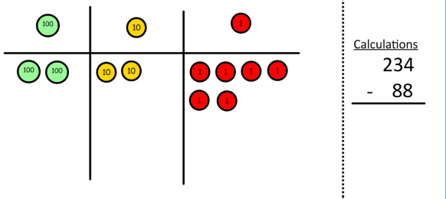

Now look at the tens, can I take away 8 tens easily? I need to exchange one hundred for ten tens.

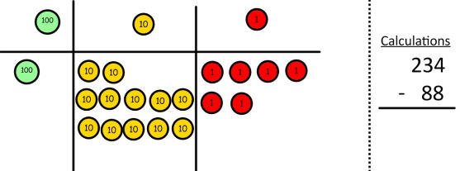

Now I can take away eight tens and complete my subtraction

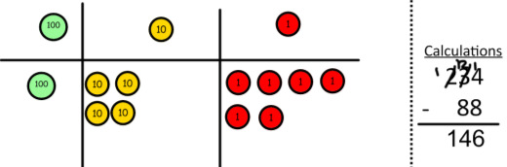

Show children how the concrete method links to the written method alongside your working. Cross out the numbers when exchanging and show where we write our new amount.







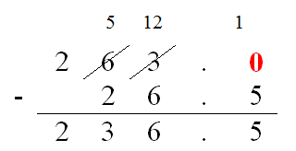

Count in multiples of a

Write sequences with multiples of numbers.

2, 4, 6, 8, 10

5, 10, 15, 20, 25 , 30

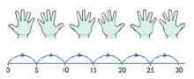

Use a number line or pictures to continue support in counting in multiples.

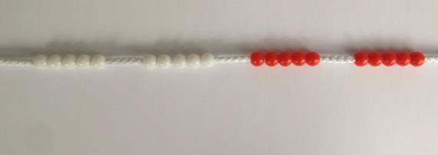

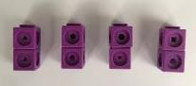

Count in multiples supported by concrete objects in equal groups.

Counting in multiples

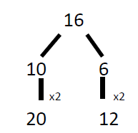

Partition a number and then double each part before recombining it back together.

Draw pictures to show how to double a number.

Use practical activities to show how to double a number.

Doubling

Abstract

Pictorial

Concrete

Objective and

Strategies

number aloud.

Multiplication



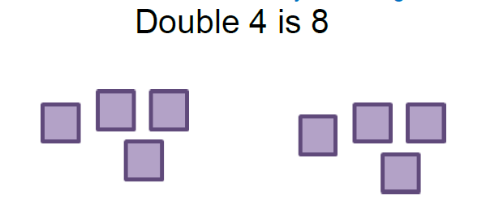







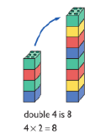

Use an array to write reinforce repeated addition.

Draw arrays in different rotations to find **commutative** multiplication sentences.

Link arrays to area of rectangles.

Create arrays using countersl cubes to show multiplication sentences.

Arrays- showing

commutative multiplication

Write addition sentences to pictures.

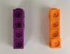

Use different objects to add equal groups.

Repeated addition

multiplication sentences and

describe objects and

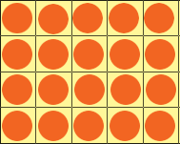

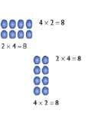

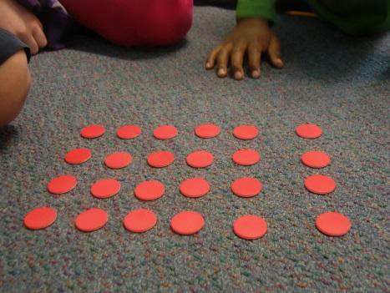

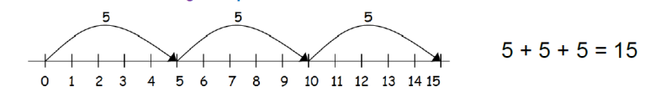





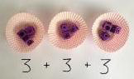

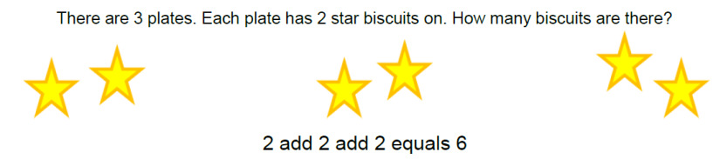

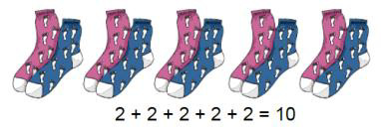

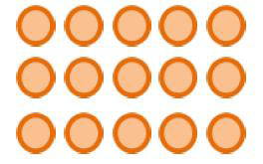

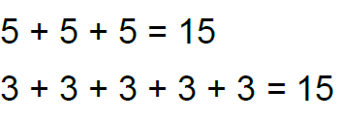





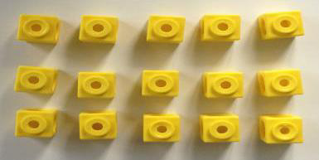

Start with multiplying by

showing the clear addition alongside the grid.

Moving forward, multiply by a 2 digit number showing the different rows within the

Children can represent the work they have done with place value counters in a way that they understand.

They can draw the counters, using colours to show different amounts or just use circles in the different columns to show their thinking as shown below.

Show the link with arrays to first introduce the grid method.

4 rows of 10

4 rows of 3

Move on to using Base 10 to move towards a more compact method.

4 rows of 13

Move on to place value counters to show how we are finding groups of a number.We are multiplying by 4 so we need 4 rows.

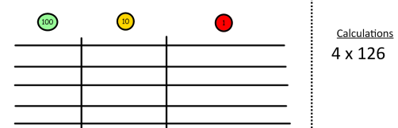

Fill each row with 126.

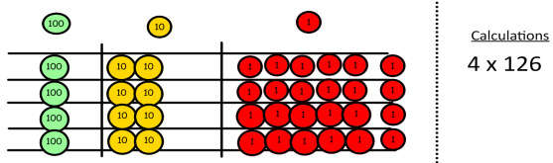

Add up each column, starting with the ones making any exchanges needed.

Then you have your answer.

Grid Method

grid method.

one digit numbers and

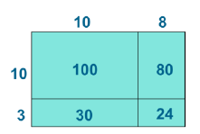

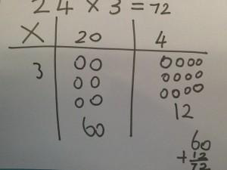





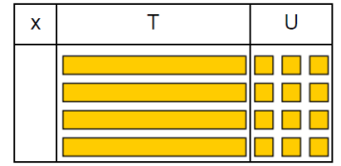

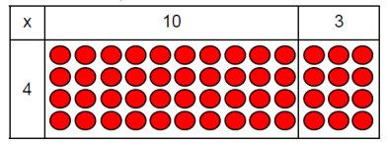

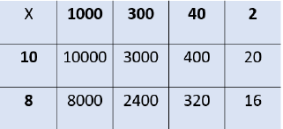

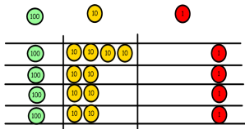

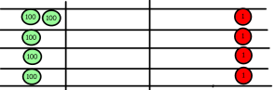

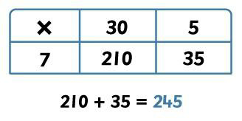

Start with long

children about lining up their numbers clearly in columns.

If it helps, children can write out what they are solving next to their answer.

This moves to the more compact method.

Bar modelling and number lines can support learners when solving problems with multiplication alongside the formal written methods.

Children can continue to be supported by place value counters at the stage of multiplication.

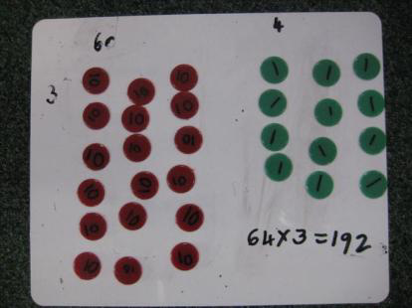

It is important at this stage that they always multiply the ones first and note down their answer followed by the tens which they note below.

Column multiplication

multiplication, reminding the



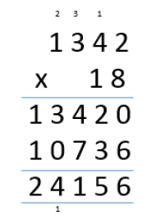

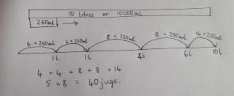

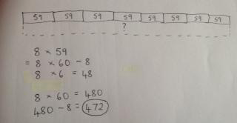

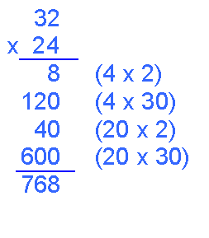

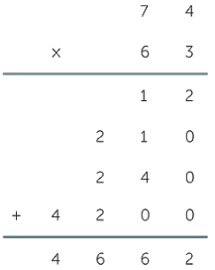

28 + 7 = 4

Divide 28 into 7 groups. How many are in each group?

Use a number line to show jumps in groups. The number

Think of the bar as a whole. Split it into the number of groups you are dividing by and work out how many would be within each group.

Divide quantities into equal groups. Use cubes, counters, objects or place value counters to aid understanding.

Division as grouping

Share 9 buns between three

9 + 3 = 3

Children use pictures or shapes to share quantities.





8 + 2 = 4

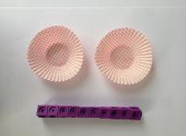

I have 10 cubes, can you share them equally in 2 groups?

Sharing objects into

groups

Abstract

Pictorial

Concrete

Objective and

Strategies

of jumps equals the number of groups.

people.

Division

















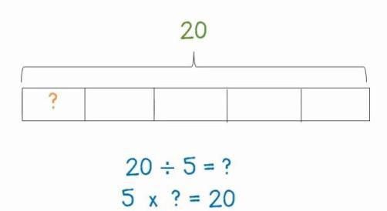

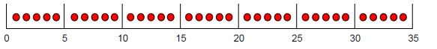



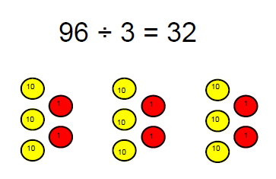

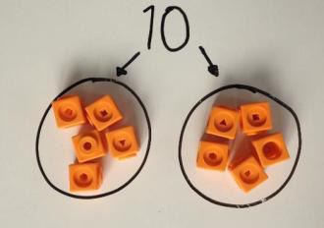

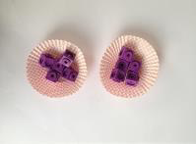



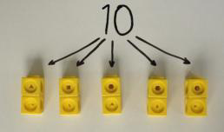

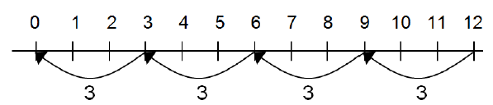

Complete written divisions using r.

Jump forward in equal jumps on a number line then see how many more you need to jump to find a remainder.

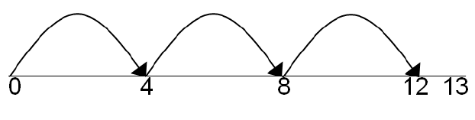

Draw dots and group them to divide an amount and clearly show a remainder.

14 + 3 =

Divide objects between groups and see how much is left over

Division with a remainder

Find the inverse of

sentences by creating four linking number sentences.

7 x 4 = 28

4 x 7 = 28

28 + 7 = 4

28 + 4 = 7

Draw an array and use lines to split the array into groups to make multiplication and division sentences.

Link division to multiplication by creating an array and thinking about the

number sentences that can be created.

Eg 15 + 3 = 5 5 x 3 = 15

15 + 5 = 3 3 x 5 = 15

Division within arrays

and show the remainder

multiplication and division

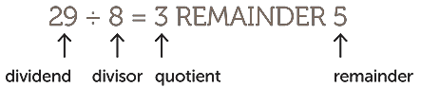

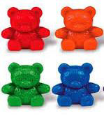







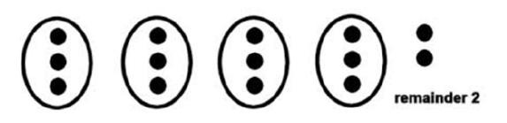

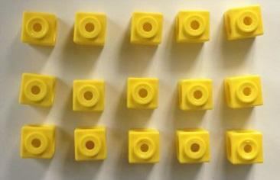

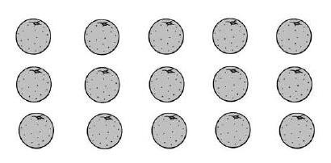

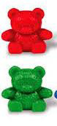

Begin with divisions that remainder.

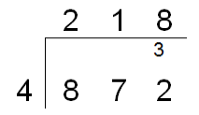

Move onto divisions with a remainder.

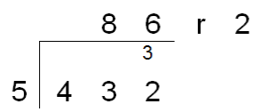

Finally move into decimal places to divide the total accurately.

Students can continue to use drawn diagrams with dots or circles to help them divide numbers into equal groups.

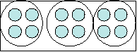

Encourage them to move towards counting in multiples to

Use place value counters to divide using the bus stop method alongside

42 + 3=

Start with the biggest place value, we are sharing 40 into three groups. We can put 1 ten in each group and we have 1 ten left over.

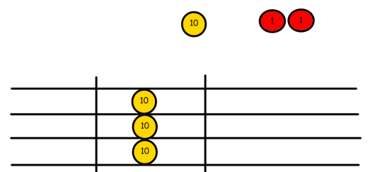

We exchange this ten for ten ones and then share the ones equally among the groups.

We look how much in 1 group so the answer is 14.

Short division

divide more efficiently.

divide equally with no



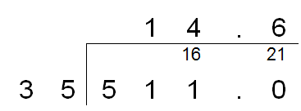

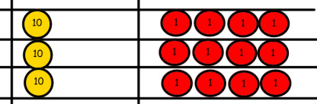







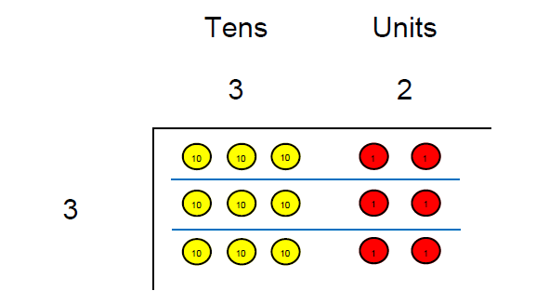

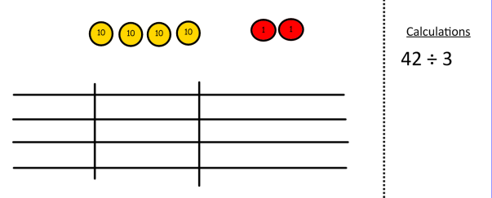

|  |  |
| --- | --- |
| Long division  Chunking method | When the divisor is more than 12, the short method (bus stop) is not an appropriate method. Long division strategies must be used. Long division strategies are complex, hence why they are worth 2 marks in SATs questions. The strategy requires knowledge of times tables, repeated addition and subtraction and multiplication by 10, 100 and 1000.   1. Children use their repeated addition skills to create multiples of 15. 2. They subtract the largest multiple of 15 away from the starting number. They do this by multiplying the divisible or its multiples by 10,100 or 1000. In this case, 300 is taken away from 432. 300 is known as 20 lots of 15. 3. The process is repeated until no more can be taken away.   (20)   1. They add the brackets (lots of 15). 2. Anything left over at the end is known as the remainder and can be displayed as a remainder, fraction or decimal.   (8) |
| Long division  Drop down method | Alternative strategies can be used by children to find the answers to these types of problems. The drop down method is also a recognised formal method for finding solutions to these types of questions.   1. Complete multiples of the divisible number to support with the subtraction as seen on the right of the image. 2. See how many “lots of” the divisible can go into the number inside the division in the same way you would with a short division question. 3. The whole amount that can go into the number inside the bus stop is displayed on top of the bus stop. 4. The child must take away the multiple of the divisible as shown on the image on the left. 5. Once they have completed the subtraction, they must “drop” the next number down to go with the number left after the subtraction. 6. The child repeats the process until they either reach 0 or the number is smaller than the divisible. 7. If there is a number left at the end of the process, this is your remainder. This can be displayed as a remainder, fraction or decimal. |