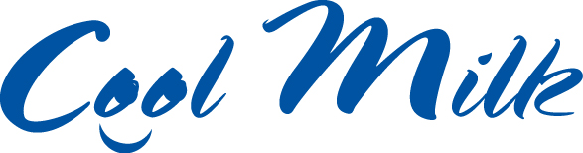
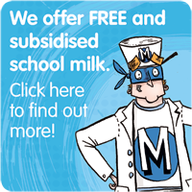
To use the link, use Ctrl and click on the link at the same time.

The Bramble Academy works with Cool Milk to provide fresh milk daily to our children.

All children under the age of 5 are able to have a FREE 189ml (third of a pint) carton of semi-skimmed milk every day as well as any child over the age of 5 who are entitled to Free School Meals.

Any child over the age of 5 can have milk at a subsidised rate of around £15 per term or 23p a day.
School milk provides your child with essential nutrients such as calcium and protein, for strong, healthy teeth and bones. It is also rehydrating and energy boosting, helping to bridge the long gap between breakfast and lunch so children stay focused.

To register your child
1. Go to www.coolmilk.com or pick up a form from school.
2. Register or pay by a Tuesday for your child’s milk to start the following week. You can pay Cool Milk online, over the phone on 0844 854 2913, at a local PayPoint or by cheque in instalments to suit you.
Free milk will continue until the Friday before your child’s fifth birthday. You will receive a payment request three weeks before this time - if you wish for your child to continue to receive school milk simply make a payment.

