The Bramble Academy
Mathematics Policy

Document Owner | Anna Harper
Version | 1
Effective From | September 2023
Next Review Date | September 2024

Purposes
The aims of mathematics are closely related to the general aims of Primary Education. Children will acquire skills of both language and number and will experience a variety of methods of learning. They will learn to think logically, discover, explore and in doing so, will begin to make sense of the world in which they live. To ensure this, they will acquire a range of mathematical experience, relevant mathematical language and skills to be able to solve mathematical problems with confidence. We strive to develop strategies which allow inclusion by all in Maths lessons. We aim to ensure that each child will develop:
- a positive attitude to mathematics as an interesting and attractive subject
- an ability to think clearly and logically in mathematics with confidence, independence of thought and flexibility of mind
- an awareness of the uses of mathematics in the world beyond the classroom
- an understanding that mathematics will frequently help them to solve problems they meet in everyday life
- an appreciation of the nature of numbers and of space, and therefore an awareness of the basic structure of mathematics
- self-motivation and aspiration to persevere and succeed
- a perception that Maths is fun and enjoyable
- a resilient attitude towards solving problems
These aims will be met by increasing confidence in mathematics through a process of enquiry and experiment. The aims will be evident in the children's ability to express ideas fluently, to talk about the subject with assurance and to use the language of mathematics confidently and in the appropriate context.
What might you typically see in the lessons?
Our school is following the Mathematics Mastery approach in Years one to six.
The following are what you would expect to see in a sequence of lessons at The Bramble Academy:
- Children develop a strong foundation of mathematical concepts (fluency) so they can complete problems with increased accuracy and confidence. Children will have the opportunity to develop a skill before being moved onto more challenging learning.
- Children will use reasoning skills to answer different types of questions. This includes questions where children explain how procedures work or where they have to identify mistakes and explain where something has been completed incorrectly. This stage of learning allows the teacher to highlight common misconceptions and provides the children with the opportunity to learn from other peoples’ mistakes.
- All children will access problem-solving. It is important that all children are exposed to problem solving questions as they are all expected to answer these types of questions at the end of each Key Stage. Complex problems, that are posed in different contexts, are provided where children use comprehension skills to solve problems. This step is essential in the teaching sequence because it teaches children how to use the skill in a practical scenario. Children are taught how to solve a problem rather than how to use a calculation.
- Resources and appropriate scaffolds are provided to aid the children’s understanding – this strategy echoes the mastery approach. All pupils are shown why their methods work, building a conceptual understanding by moving through the concrete-pictorial-abstract model of Bruner. This means that pupils all have opportunities to use concrete or pictorial models to support or challenge them. We do not differentiate through outcomes unless a child is working outside the program of study.
- Arithmetic skills are taught daily. This provides children with the opportunity to practise skills, utilising the “spaced learning” theory. This increases the likelihood of information retention. Additionally, it removes any potential future barriers as they will have a strong foundation of skills to support their learning.
- Questions, regardless whether it is as fluency, reasoning or problem-solving, are posed in a variety of ways so children develop flexibility when solving problems.
- Pre-assessment and pre-teaching is used to help diminish the difference for the bottom 20% of learners before the start of the teaching sequence. Early identification of misconceptions enables teachers to provide suitable intervention so learning is not lost in the first lesson. This also has a positive impact on children’s perception of maths as they feel more success from earlier in the sequence.
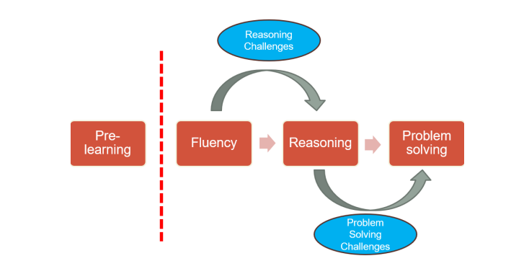

Visual representation of the teaching sequence for Maths at The Bramble Academy

Our aim is to ensure that all pupils:
- have a strong foundation of the arithmetic strategies in maths as this breaks down barriers to future learning as well as making the child more confident about new learning.
- are able to identify their own mistakes as a result of extensive reasoning practice.
- have a thorough understanding of mathematical language used in complex questions so they can solve problems with greater ease.
Cross-curricular mathematical opportunities
Teachers will seek to take advantage of opportunities to make cross-curricular links. They will plan for pupils to practise and apply the skills, knowledge and understanding acquired through mathematics lessons to other areas of the curriculum where appropriate. Strategic subject leaders communicate with each other to see where cross-curricular opportunities can be utilised.
Assessment
Formative Assessment (Assessment for Learning):
- Brief ‘pre-learning’ assessments are given to the children, thus enabling teachers to provide pre-teaching to close the gap as well as being able to correctly pitch the first lesson;
- High order questioning is used to identify misconceptions and deepen children’s understanding;
- Feedback is precisely provided and it further promotes progress by clearly identifying next steps or areas to consider further;
- Children will work collaboratively to identify areas for improvement/address misconceptions (peer assessment).

Summative Assessment:
- Termly tests in mathematics will be undertaken across school.
- Teachers complete gap analysis of the tests that are completed so they can identify which children require further support through specific teaching and interventions.

